

**Project 1:** Application

**Topic:** MapPet pet café in Thailand

Miss Nuttida Napakas 6188033

Mister Phakin A-Yamuang 6188066

Miss Tanyalak Srianong 6188095

Section 1

Presented to

Lect. Snit Sanghlao

A Report Submitted in partial fulfillment of the Requirements for

ITCS424 Wireless and Mobile Computing

Faculty of Information and Communication Technology Mahidol University

**Date** April 16, 2021

**Content**

**Topic Page**

Project Overview

The Purpose of the Project

1. The User Business or Background of the Project Effort
2. Goals of the Project
3. Measurement

The Scope of the Work

1. The Current Situation
2. The Context of the Work
3. Work Partitioning
4. Competing Products

Product Scenarios

1. Product Scenario List
2. Individual Product Scenarios

Relevant Facts and Assumptions

1. Facts
2. Assumptions

Product Use Cases

1. Use Case Diagrams
2. Product Use Case List
3. Individual Product Use Cases

Functional Requirements

Data Requirements

Performance Requirements

Security Requirements

Look and Feel Requirements

System Design

Subsystem services

User Interface

Object Design

1. Packages
2. Class Interfaces

**Project Overview**

This project stands for pet lovers who are interested in animals. Therefore, people who love to chill out at the cafe can use this application to find the pet cafe that they pleased. Our team members want to make a perfect application for pet lovers which is a pet cafe location application in the name of “**MapPet**”. The problem statement of this project is pet lovers don't have any idea about pet cafe. For this reason, our application will help them to find the nearest pet cafe and also show the recommended cafe for them.

There are three options for pet lovers as follows: dog, cat, and exotic pet. The users can select an option for the type of pet they want to play with, then the application will suggest the nearest location of the cafe and it suggests the location of the other recommended cafe as well. The users can decide by seeing some pictures of the pet cafe which shows the style and environment of each cafe. Moreover, our application will show the rate price of food and drink of each pet cafe to make the users more comfortable to choose. After selecting the pet cafe, the application will show the map location of the pet cafe which is selected by a user. The plan of the processes of our application is presented in figure 1.

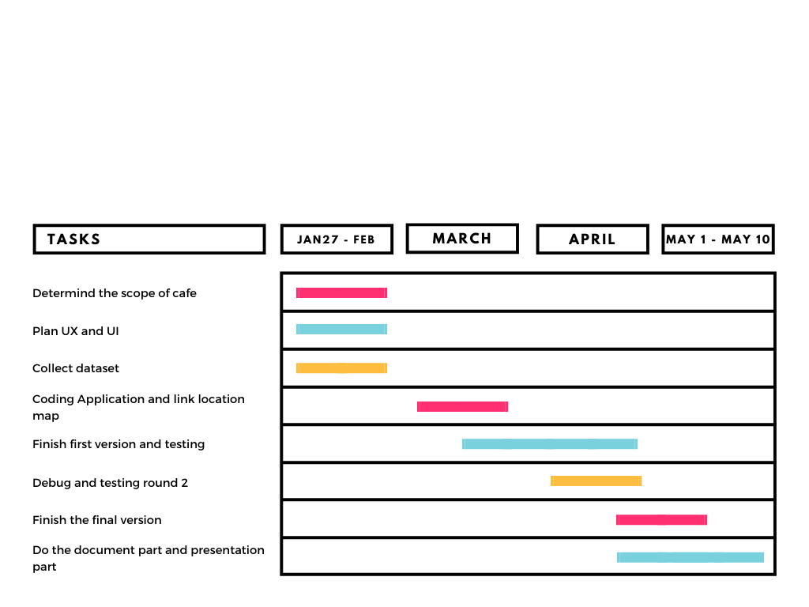

**Figure 1**: Gantt Chart of **MapPet** application

**The Purpose of the Project**

1. The User Business or Background of the Project Effort

It’s begin from our team are the [et lover and also love to go to café too, So then we would live to do the application which have pet café in Thailand.

1. Goals of the Project

The user can use our application to find the pet café in Thailand.

1. Measurement

The measurement come from the quantity of the user that download and use the application, including the vote and comment to get the feedback too.

**The Scope of the Work**

1. The Current Situation

Now, we finish every task and page in schedule process, the user can use it easily.

1. The Context of the Work

The application which come with the pet cafe

1. Work Partitioning

Tanyalak S did in data part which collect the location latitude and longitude, picture and description to show in application.

Nuttida N did in development part which built the code and implement in code.

Phakin A did in QA or Quality Assurance which check and test the code and the data.

1. Competing Products

Wongnai , klook, agoda ,and Traveloka

**Product Scenarios**

1. Product Scenario List

TBA

1. Individual Product Scenarios

TBA

**Relevant Facts and Assumptions**

1. Facts

TBA

1. Assumptions

TBA

**Product Use Cases**

1. Use Case Diagrams

TBA

1. Product Use Case List

TBA

1. Individual Product Use Cases

TBA

**Functional Requirements**

TBA

**Data Requirements**

TBA

**Performance Requirements**

TBA

**Security Requirements**

TBA

**Look and Feel Requirements**

TBA

**System Design**

TBA

**Subsystem services**

TBA

**User Interface**

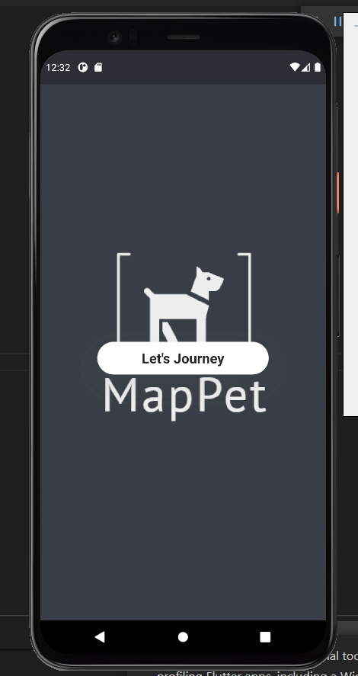 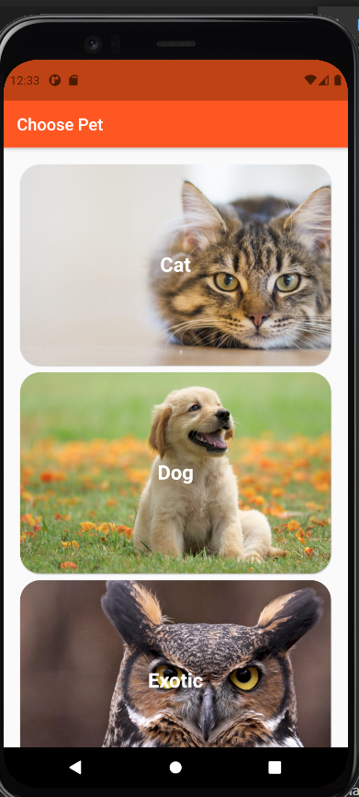 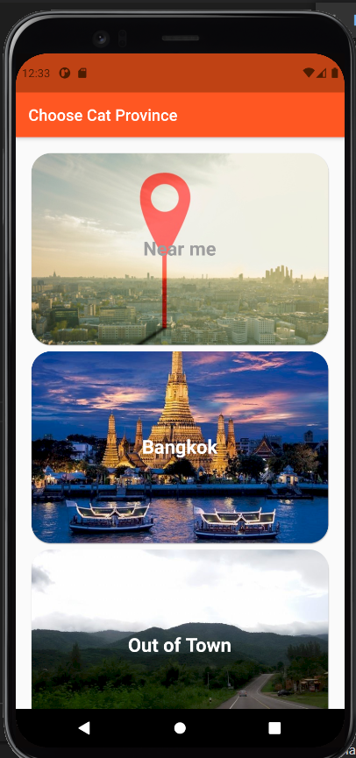

And TBA for more

**Object Design**

1. Packages

TBA

1. Class Interfaces

TBA